Report File

**INDEX**

|  |  |  |
| --- | --- | --- |
| S.  No. | Name of Experiments | Page No. |
| 1. | Introduction to Arduino Micro-Controller. | 3-4 |
| 2. | To make a circuit of blinking an LED using Arduino Uno and breadboard. | 5-8 |
| 3. | To blink multiple LEDs using Arduino Uno and breadboard. | 9-12 |
| 4. | Write a program to design a pattern of sequence of multiple LED’s using for loop in Arduino. | 13-17 |
| 5. | Write a program to demonstrate sending data from the computer to the Arduino board and control brightness of LED. | 18-20 |
| 6. | *Serial Communication:*  WAP to print following pattern using for loop.    ****************************************************  Roll No._____________________________________________  ****************************  Name: ______________________________________________  **********************************  Branch: _____________________________________________ **************************** | 21-25 |
| 7. | Write a program to change the intensity of the single LED bulb using:  i. digitalRead () ii. analogRead () | 26-31 |
| 8. | Write a program to change the intensity of the given LEDs for the sequence 35214 in for both forward and reverse order. | 32-38 |
| 9. | Write a program to demonstrate control of DC Motor using forward, backward, left, right turn motion and clock-wise/anti clock- wise rotation. | 39-42 |

# EXPERIMENT-1

**OBJECTIVE :** Introduction to Arduino Microcontroller

**HARDWARE USED :** Arduino Uno

**SOFTWARE USED :** Arduino IDE

**THEORY :**

A microcontroller is an integrated circuit (IC) device used for controlling other portions of an electronic system, usually via a microprocessor unit (MPU), memory, and some peripherals. These devices are optimized for embedded applications that require both processing functionality and agile, responsive interaction with digital, analog, or electromechanical components.

Microcontrollers are used in automatically controlled products and devices, such as automobile engine control systems, implantable medical devices, remote controls, office machines, appliances, power tools, toys and other embedded systems. By reducing the size and cost compared to a design that uses a separate microprocessor, memory, and input/output devices, microcontrollers make it economical to digitally control even more devices and processes.

**i.** Power USB: Arduino board can be provided power from PC/laptop using power cable **ii.** Power Jack: Arduino can be powered directly from the AC power supply.

**iii.** Reset Button: It is used to reset the Arduino board i.e., start programming from beginning. **iv.** Pins: Used to connect different components to the Arduino board, voltage and ground connections.

**v.** Analog Pins: Used to read analog signals from analog sensors and converts it into digital signal. **vi.** Digital Pins: These pins can be configured to work a input or output pins to read logics (0 and 1).

1. Power Pins: Pins that provide power (operating voltage) and ground connections.
2. ATmega328P Microcontroller: It is a high performance yet low power consumption 8bit AVR microcontroller. It can be commonly found in Arduino boards such as Arduino Uno. It is also known as the brain of Arduino.

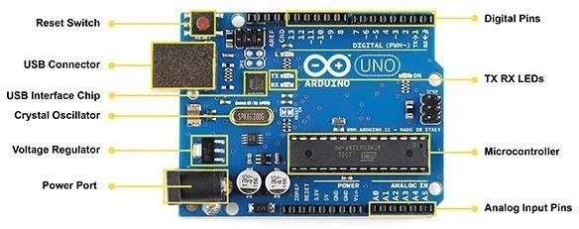

**RESULT ANALYSIS :**

We were able to analyze the parts required in a buggy i.e. Nvis 3302ARD RoboCar with the help of this Arduino microcontroller. It is one of the most important parts of the project, hence would help us design our own Robocar.

# EXPERIMENT-2

**OBJECTIVE** :Write a program to blink a single LED using Arduino and breadboard.

**HARDWARE USED :** Arduino Uno, Breadboard, LED, Jumper Wires,Resistor.

**SOFTWARE USED:** Tinkercad Simulator.

**THEORY:**

**Resistor:** Resistors are used in virtually all electronic circuits and many electrical ones. Resistors, as their name indicates resist the flow of electricity and this function is key to the operation most circuits.

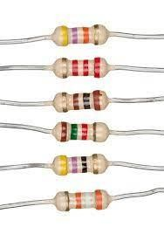

**LED:** A light-emitting diode (LED) is a semiconductor light source that emits light when current flows through it. Electrons in the semiconductor recombine with electron holes, releasing energy in the form of photons (Energy packets).

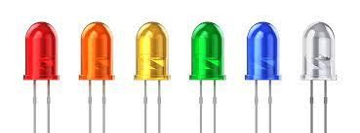

**Arduino Uno Board:** The **Arduino Uno** is an [open-source](https://en.wikipedia.org/wiki/Open-source) [microcontroller board](https://en.wikipedia.org/wiki/Microcontroller_board) based on the [Microchip](https://en.wikipedia.org/wiki/Microchip_Technology) [ATmega328P](https://en.wikipedia.org/wiki/ATmega328P) microcontroller and developed by [Arduino.cc.](https://en.wikipedia.org/wiki/Arduino)

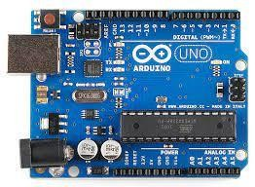

**Breadboard:** A breadboard is used to place components (resistor, capacitor, LED’s etc.) that are wired together. It is used to make temporary circuits.

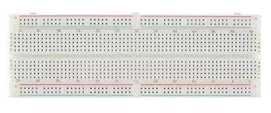

**Jumper Wires:** A jumper wire is an electric wire that connects remote electric circuits used for printed circuit boards.

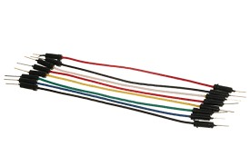

**TINKERCAD DIAGRAM :**

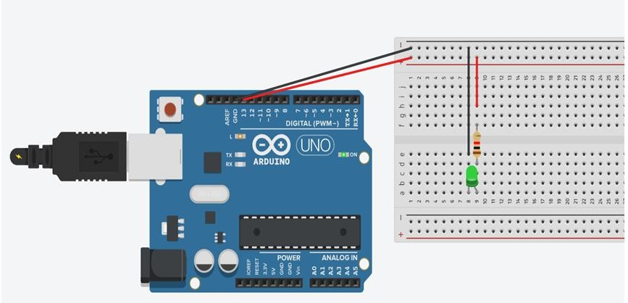

**CIRCUIT DIAGRAM :**

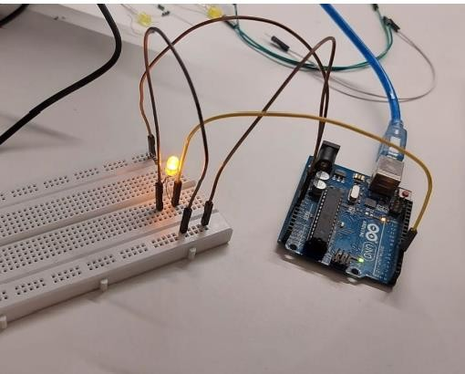

**CODE :**

int ledPin = 7; void setup()

{

pinMode(ledPin, OUTPUT);

} void loop()

{ digitalWrite(ledPin, HIGH); delay(1000); digitalWrite(ledPin, LOW); delay(1000);

}

**RESULT ANALYSIS :**

In this experiment, we have learnt how we can select the pin of an Arduino board and set it HIGH or LOW depending upon the usage. The delay time between the transition for the desired interval time could be set giving the common.

# EXPERIMENT-3

**OBJECTIVE** :To blink multiple LED’s using Arduino uno and breadboard.

**HARDWARE USED :** Arduino Uno, Breadboard, LED, Jumper Wires,Resistor.

**SOFTWARE USED :** Tinkercad Simulator.

**THEORY :**

1. Resistor: A two terminal device in circuits, resistors are used to reduce current flow, adjust signal levels, to divide voltages, bias active elements, and terminate transmission lines.
2. Arduino: An Arduino Uno is an open source microcontroller board which is developed with multiple analog and digital input output pins that may be interacted to various circuits.
3. Breadboard: A breadboard is a rectangular plastic board with a bunch of tiny holes in it which let in to easily insert electronic components to prototype.
4. Connecting Wires: It provides a medium to an electrical current so that they can travel from one point on a circuit to another
5. LED: A light-emitting diode (LED) is a semiconductor light source that emits light when current flows through it. Electrons in the semiconductor recombine with electron holes, releasing energy in the form of photons (Energy packets).

**TINKERCAD DIAGRAM :**

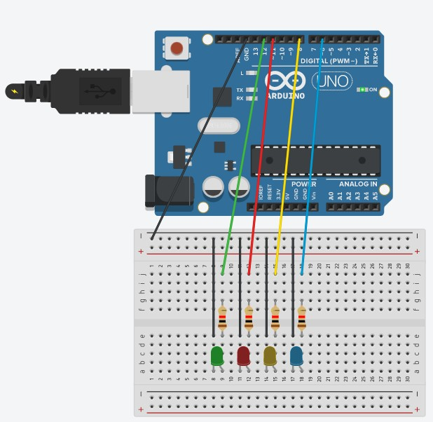

**CIRCUIT DIAGRAM :**

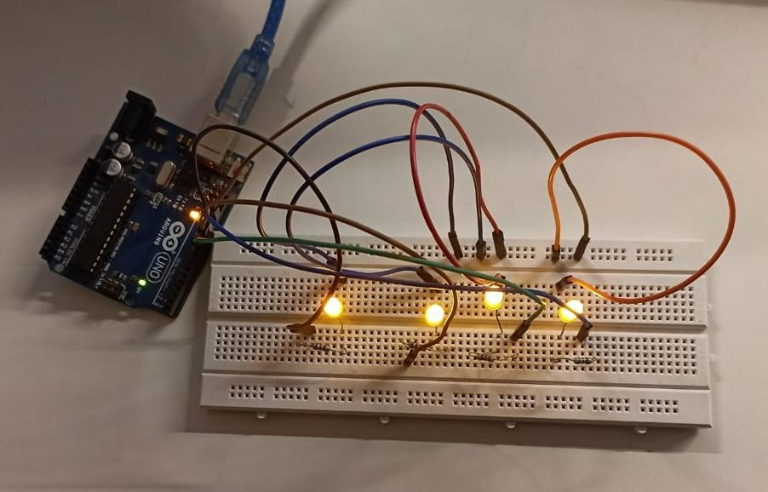

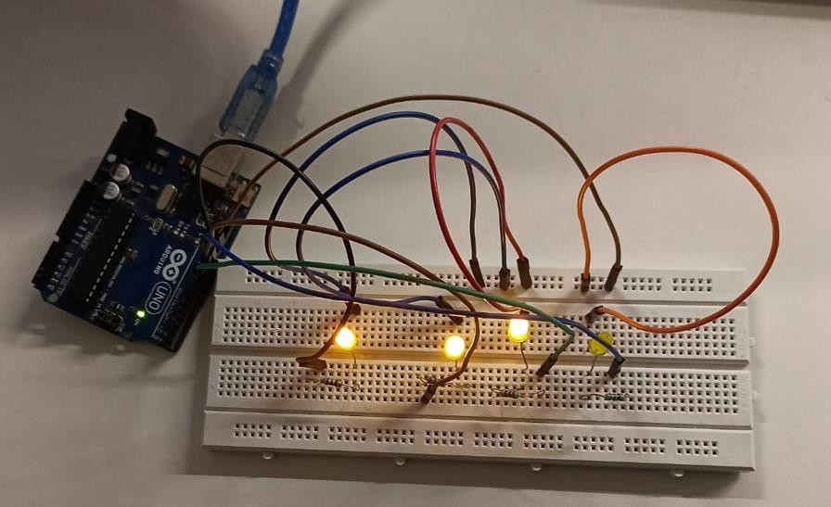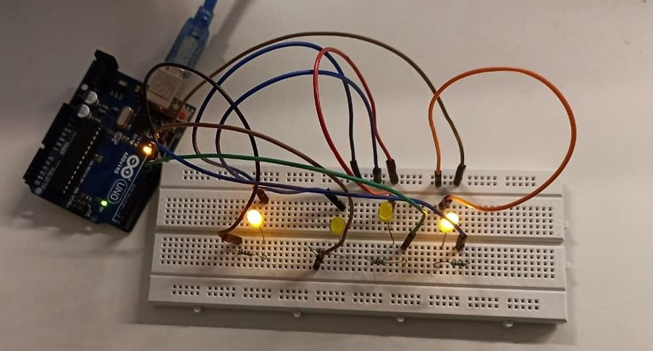

**CODE :**

void setup()

{

pinMode(13 , OUTPUT); pinMode(12 , OUTPUT); pinMode(11 , OUTPUT); pinMode(10 , OUTPUT);

}

void loop()

{

digitalWrite(13 , HIGH); digitalWrite(12 , LOW); digitalWrite(11 , LOW); digitalWrite(10 , LOW); delay(1000); digitalWrite(13 , LOW); digitalWrite(12 , HIGH); digitalWrite(11 , LOW); digitalWrite(10 , LOW); delay(1000); digitalWrite(13 , LOW); digitalWrite(12 , LOW); digitalWrite(11 , HIGH); digitalWrite(10 , LOW); delay(1000); digitalWrite(13 , LOW); digitalWrite(12 , LOW); digitalWrite(11 , LOW); digitalWrite(10 , HIGH); delay(1000);

}

**RESULT ANALYSIS :**

In this experiment, we have learnt how to blink multiple LEDs at the same time or at different time. We have also learnt to use the delay() efficiently to create a pattern of our choice.

# EXPERIMENT- 4

**OBJECTIVE :** Write a program to design a pattern of sequence of multiple LED’s using for loop in Arduino.

**HARDWARE USED :**

|  |  |  |
| --- | --- | --- |
| **Sr. No** | **Name of Components** | **Value** |
| 1. | Resistor | 220 Ω |
| 2. | Light Emitting Diode | Multicolour |
| 3. | Arduino Uno R3 | NA |
| 4. | Breadboard | NA |
| 5. | Connecting Wires | NA |
| 6. | USB cable | NA |

**SOFTWARE USED :** Tinkercad Simulator

**TINKERCAD DIAGRAM :**

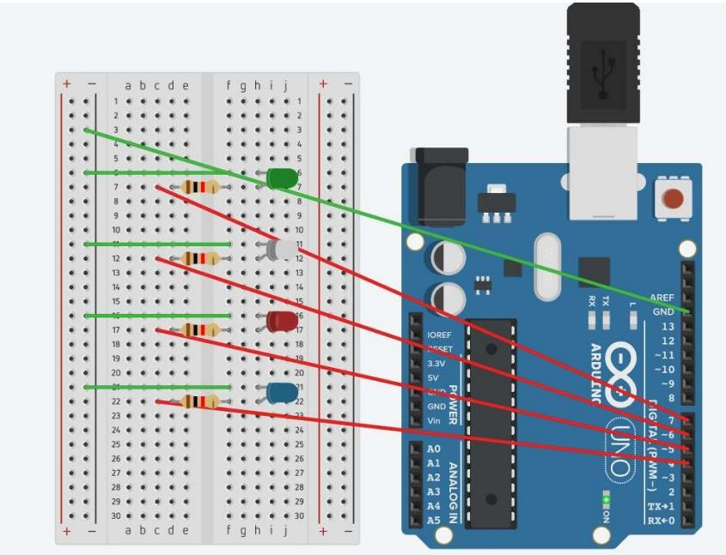

**THEORY:**

1. Resistor: A two terminal device in circuits, resistors are used to reduce current flow, adjust signal levels, to [divide voltages, bias a](https://en.wikipedia.org/wiki/Voltage_divider)ctive elements, and terminate [transmission lines.](https://en.wikipedia.org/wiki/Transmission_line)
2. Arduino: An Arduino Uno is an open source microcontroller board which is developed with multipleanalog and digital input output pins that may be interacted to various circuits.

1. Breadboard: A breadboard is a rectangular plastic board with a bunch of tiny holes in it which let in toeasily insert electronic components to prototype.

1. Connecting Wires: It provides a medium to an electrical current so that they can travel from one point on acircuit to another.

**CIRCUIT DIAGRAM:**

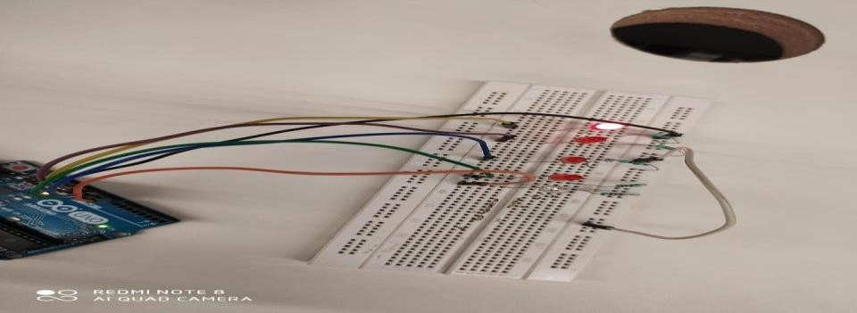

**CODE:**

const int led1 = 10; const int led2 = 11; const int led3 = 12; const int led4 = 13; int number = 0; void setup() { pinMode(led1, OUTPUT); pinMode(led2, OUTPUT); pinMode(led3, OUTPUT); pinMode(led4, OUTPUT);

} void loop() {

for (number = 0; number <= 15; number++) { digitalWrite(led1, number & 1); digitalWrite(led2, (number >> 1) & 1); digitalWrite(led3, (number >> 2) & 1); digitalWrite(led4, (number >> 3) & 1); delay(4000);

}

}

PATTERN 1(1010 0101)

// Pin definitions const int led1 = 10; const int led2 = 11; const int led3 = 12; const int led4 = 13; void setup() {

// Set the pin modes for each LED pinMode(led1, OUTPUT); pinMode(led2, OUTPUT); pinMode(led3, OUTPUT); pinMode(led4, OUTPUT);

} void loop() { digitalWrite(led1, HIGH); digitalWrite(led3, HIGH); delay(1000); digitalWrite(led1, LOW); digitalWrite(led3, LOW); digitalWrite(led2, HIGH); digitalWrite(led4, HIGH); delay(1000); digitalWrite(led2, LOW); digitalWrite(led4, LOW); delay(2000);

}

PATTERN 2 (1001 0110): // Pin definitions const int led1 = 10; const int led2 = 11; const int led3 = 12; const int led4 = 13; void setup() { // Set the pin modes for each LED pinMode(led1, OUTPUT); pinMode(led2, OUTPUT); pinMode(led3, OUTPUT); pinMode(led4, OUTPUT);

}

void loop() { digitalWrite(led1, HIGH); digitalWrite(led4, HIGH); delay(1000); digitalWrite(led1, LOW); digitalWrite(led4, LOW); digitalWrite(led2, HIGH); digitalWrite(led3, HIGH); delay(1000);

digitalWrite(led2, LOW); digitalWrite(led3, LOW); delay(2000);

}

**RESULT ANALYSIS:-**

In this experiment we wrote an arduino program to design and simulate both pattern 1 forward(1010) and reverse pattern (0101) and pattern 2 forward(1001) and reverse pattern (0110) sequence for different color LEDs using *for* function.

# EXPERIMENT- 5

**OBJECTIVE :** Write a program to demonstrate sending data from the computer to Arduino board and control brightness of LED

**HARDWARE USED :**

1. Arduino Board
2. LED
3. 220 ohm resistor

**THEORY** :

**Communication between computer and Arduino**: To send data from a computer to an Arduino board, we need to establish a communication channel between the two. This can be done through various methods such as USB, serial, or Bluetooth communication. For this demonstration, we will use a USB cable to connect the computer and the Arduino board.

1. **Serial Communication:** The USB cable will provide a serial communication channel between the computer and the Arduino board. To make use of this channel, we need to install a serial library in the Arduino programming environment. This library will provide functions for sending and receiving data over the serial port.

1. **Sending Data from Computer:** From the computer side, we need a program that can send data over the serial port. This program can be written in any programming language such as Python, C++, or Java. For this demonstration, we will use Python as our programming language. The program will use a library for serial communication, such as PySerial, to send data over the serial port to the Arduino board.

1. **Receiving Data on Arduino:** On the Arduino side, we need to write a program that can receive the data sent from the computer and control the brightness of an

LED accordingly. The program will use the serial library to receive the data over

the serial port and store it in a variable.

1. **Controlling Brightness of LED:** The program will use Pulse Width Modulation (PWM) to control the brightness of the LED. PWM allows us to control the average voltage applied to the LED, which in turn controls its brightness. The program will use the received data to set the duty cycle of the PWM signal and control the brightness of the LED.

1. **Final Output:** After running the computer program and uploading the Arduino program, we should be able to control the brightness of the LED by sending data from the computer to the Arduino board. The brightness of the LED will change based on the data sent by the computer, allowing us to control it remotely.

**TINKERCAD DIAGRAM :**

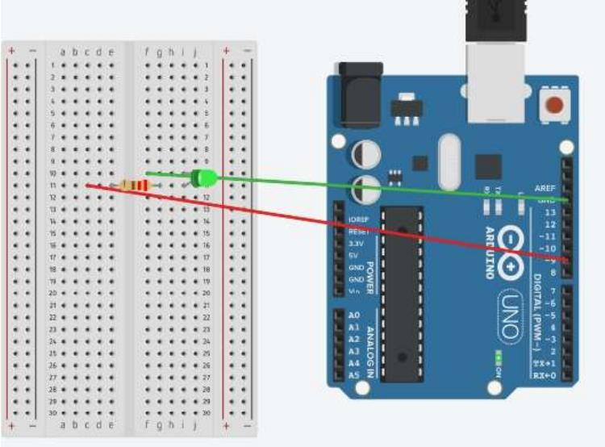

**CODE:**

int LED = 9; // LED is connected to digital pin 9

void setup() {

pinMode(LED, OUTPUT); // Set LED pin as output

Serial.begin(9600); // Start serial communication at 9600 baud rate }

void loop() { if (Serial.available() > 0) { int brightness = Serial.parseInt(); // Read data from serial port analogWrite(LED, brightness); // Set LED brightness using analogWrite function

}

}

**RESULT :**

The result of the above experiment, when you upload the program to an Arduino board and run it, is that the brightness of the LED connected to digital pin 9 will change based on the data received from the computer via the serial connection.

You can send data from the computer to the Arduino board using a serial monitor tool in the Arduino Integrated Development Environment (IDE) or another serial communication software. By sending a value between 0 and 255, you can control the brightness of the LED, where 0 represents off and 255 represents maximum brightness.

# EXPERIMENT-6

**OBJECTIVE : *Serial Communication :***

WAP to print following pattern using for loop.

****************************************************

Roll No._____________________________________________ ****************************

Name: ______________________________________________

**********************************

Branch: _____________________________________________

****************************

**SOFTWARE USED:** Arduino IDE

**HARDWARE USED:**

|  |  |  |
| --- | --- | --- |
| S No. | Name of Component | Value |
| 1 | Arduino UNO Board | 1 |
| 2 | Cable For Arduino Uno/MEGA (USB A to B) | 1 |

**THEORY :**

A microcontroller is an integrated circuit (IC) device used for controlling other portions of an electronic system, usually via a microprocessor unit (MPU), memory, and some peripherals. These devices are optimized for embedded applications that require both processing functionality and agile, responsive interaction with digital, analog, or electromechanical components.

Microcontrollers are used in automatically controlled products and devices, such as automobile engine control systems, implantable medical devices, remote controls, office machines, appliances, power tools, toys and other embedded systems. By reducing the size and cost compared to a design that uses a separate microprocessor, memory, and input/output devices, microcontrollers make it economical to digitally control even more devices and processes.

**ix.** Power USB: Arduino board can be provided power from PC/laptop using power cable **x.** Power Jack: Arduino can be powered directly from the AC power supply.

**xi.** Reset Button: It is used to reset the Arduino board i.e., start programming from beginning. **xii.** Pins: Used to connect different components to the Arduino board, voltage and ground connections. **xiii.** Analog Pins: Used to read analog signals from analog sensors and converts it into digital signal. **xiv.** Digital Pins: These pins can be configured to work a input or output pins to read logics (0 and 1).

1. Power Pins: Pins that provide power (operating voltage) and ground connections.
2. ATmega328P Microcontroller: It is a high performance yet low power consumption 8bit AVR microcontroller. It can be commonly found in Arduino boards such as Arduino Uno. It is also known as the brain of Arduino.

**Tinker cad Diagram:**



**Circuit Diagram:**

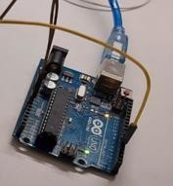

**CODE:**

void setup() { Serial.begin(9600);

}

void loop() {

Serial.println();

Serial.print("Objective:WAP to print following pattern using for loop."); Serial.println(); for(int i = 0 ; i < 60 ; i++)

{

Serial.print("*");

}

Serial.println(); Serial.print("Roll No."); for(int i = 0 ; i < 25 ; i++)

{

Serial.print("_");

}

Serial.println(); for(int i = 0 ; i < 45 ; i++)

{

Serial.print("*");

}

Serial.println(); Serial.print("Name: "); for(int i = 0 ; i < 25 ; i++)

{

Serial.print("_");

}

Serial.println(); for(int i = 0 ; i < 35 ; i++)

{

Serial.print("*");

}

Serial.println(); Serial.print("Branch: "); for(int i = 0 ; i < 50 ; i++)

{

Serial.print("_");

}

Serial.println(); for(int i = 0 ; i < 30 ; i++)

{

Serial.print("*");

}

}

**Result Analysis :**

In this experiment, we have learnt how to use SerialCommunication and use Arduino UNO Serial Monitor.

# EXPERIMENT-7

**OBJECTIVE** :Write a program to change the intensity of the single LED bulb using :

iii. digitalRead () ii. analogRead ().

**SOFTWARE USED:** Tinker cad Simulator.

**HARDWARE USED :**

|  |  |  |
| --- | --- | --- |
| S.No. | Name of Component | Value |
| 1 | Ardrino Uno Board | 1 |
| 2 | Cable For Arduino Uno/MEGA (USB A to B) | 1 |
| 3 | BreadBoard | 1 |
| 4 | Jumper Wire | 2 |
| 5 | LED | 1 |
| 6 | Resistor | 220 ohm |

**THEORY:**

**Arduino Uno Board:** The **Arduino Uno** is an [open-source](https://en.wikipedia.org/wiki/Open-source) [microcontroller board](https://en.wikipedia.org/wiki/Microcontroller_board) based on the [Microchip](https://en.wikipedia.org/wiki/Microchip_Technology) [ATmega328P](https://en.wikipedia.org/wiki/ATmega328P) microcontroller and developed by [Arduino.cc.](https://en.wikipedia.org/wiki/Arduino)



**Cable For Arduino Uno/MEGA (USB A to B):** This is a Cable for Arduino

UNO/MEGA (USB A to B)-1feet, you can use it to connect “Arduino Uno”, “Arduino Mega 2560″ or any board with the USB female A port of your computer.



**Breadboard:** A breadboard is used to place components (resistor, capacitor, LED’s etc.) that are wired together. It is used to make temporary circuits.



**Jumper Wires:** A jumper wire is an electric wire that connects remote electric circuits used for printed circuit boards.



**LED:** A light-emitting diode (LED) is a semiconductor light source that emits light when current flows through it. Electrons in the semiconductor recombine with electron holes, releasing energy in the form of photons (Energy packets).



**Resistor:** Resistors are used in virtually all electronic circuits and many electrical ones. Resistors, as their name indicates resist the flow of electricity and this function is key to the operation most circuits.



**TINKERCAD DIAGRAM :**

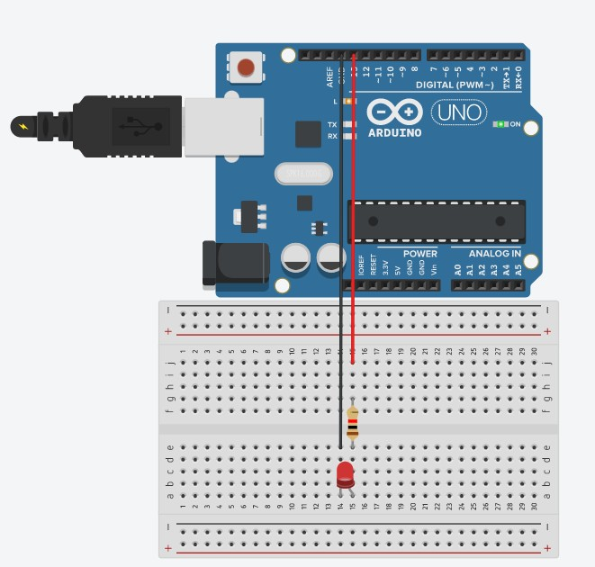

**CIRCUIT DIAGRAM:**

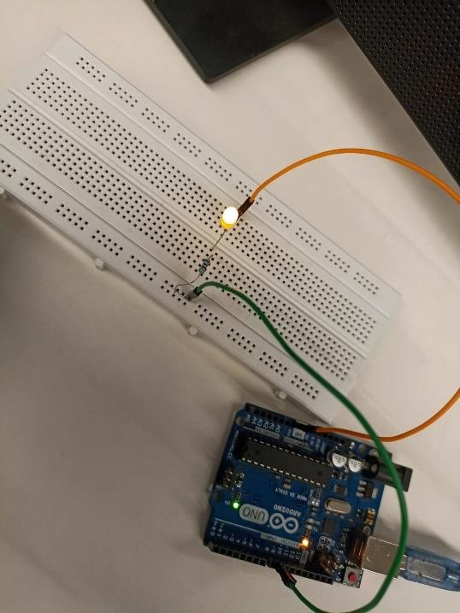

**CODE :**

(i) digitalRead ()

void setup()

{

pinMode(10,INPUT); pinMode(13,OUTPUT);

}

void loop() { int y = digitalRead(10); if(y==1)

{ for(int i = 200 ; i >= 0 ; i--)

{

analogWrite(13,i); delay(20);

} } else

{

digitalWrite(13,LOW);

}

}

(ii) analogRead ().

int a = 5; int b= 9; int value = 0; void setup() { pinMode(a,INPUT); pinMode(b,OUTPUT);

}

void loop() { value = analogRead(a); analogWrite(b,value);

}

**RESULT ANALYSIS:**

In this experiment, we have learnt how to write a program to change the intensity of the single LED bulb using digitalRead () and analogRead ().

# EXPERIMENT-8

**OBJECTIVE** :Write a program to change the intensity of the given LEDs for the sequence 35214 in for both forward and reverse order.

**SOFTWARE USED:** Tinker cad Simulator.

**HARDWARE USED :**

|  |  |  |
| --- | --- | --- |
| S.No. | Name of Component | Value |
| 1 | Ardrino Uno Board | 1 |
| 2 | Cable For Arduino Uno/MEGA (USB A to B) | 1 |
| 3 | BreadBoard | 1 |
| 4 | Jumper Wire | 10 |
| 5 | LED | 5 |
| 6 | Resistor | 220 ohm(5) |

**THEORY:**

**Arduino Uno Board:** The **Arduino Uno** is an [open-source](https://en.wikipedia.org/wiki/Open-source) [microcontroller board](https://en.wikipedia.org/wiki/Microcontroller_board) based on the [Microchip](https://en.wikipedia.org/wiki/Microchip_Technology) [ATmega328P](https://en.wikipedia.org/wiki/ATmega328P) microcontroller and developed by [Arduino.cc.](https://en.wikipedia.org/wiki/Arduino)



**Cable For Arduino Uno/MEGA (USB A to B):** This is a Cable for Arduino

UNO/MEGA (USB A to B)-1feet, you can use it to connect “Arduino Uno”, “Arduino Mega 2560″ or any board with the USB female A port of your computer.



**Breadboard:** A breadboard is used to place components (resistor, capacitor, LED’s etc.) that are wired together. It is used to make temporary circuits.



**Jumper Wires:** A jumper wire is an electric wire that connects remote electric circuits used for printed circuit boards.



**LED:** A light-emitting diode (LED) is a semiconductor light source that emits light when current flows through it. Electrons in the semiconductor recombine with electron holes, releasing energy in the form of photons (Energy packets).



**Resistor:** Resistors are used in virtually all electronic circuits and many electrical ones. Resistors, as their name indicates resist the flow of electricity and this function is key to the operation most circuits.



**TINKERCAD DIAGRAM:**

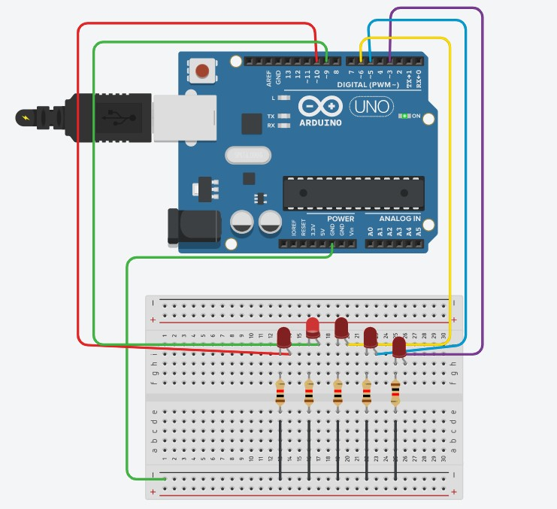

**CIRCUIT DIAGRAM:**

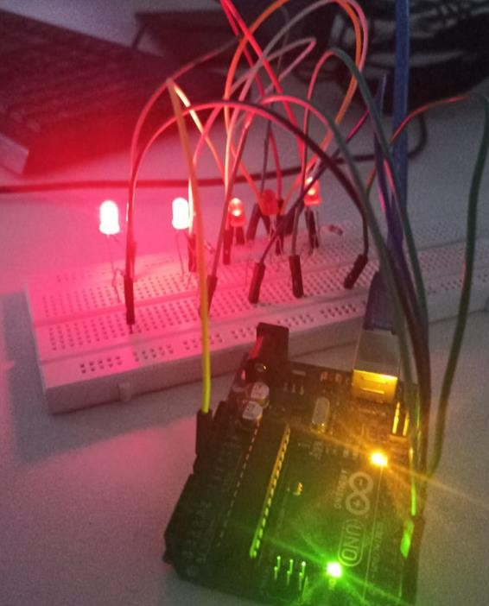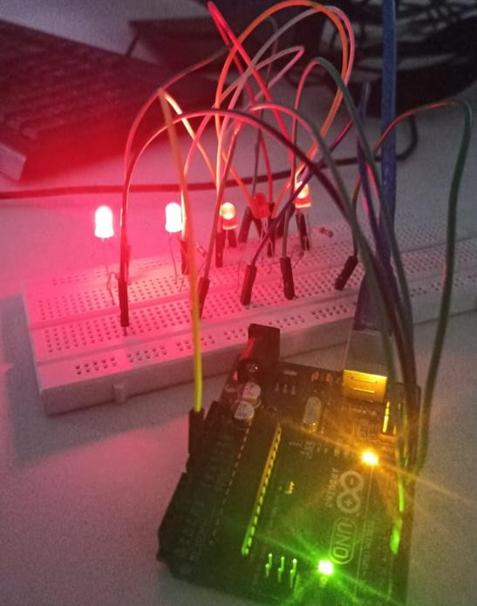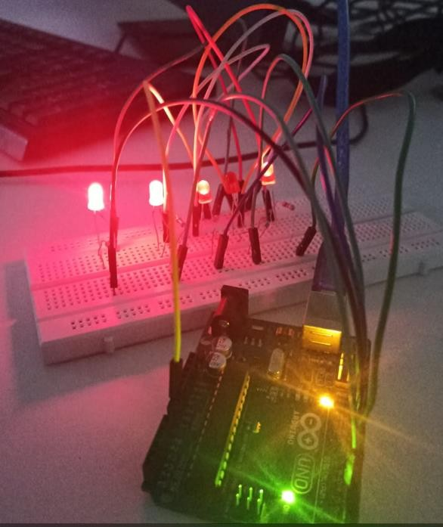

**CODE:**

int i;

const int Lpin1 = 3; const int Lpin1 = 5; const int Lpin1 = 6; const int Lpin1 = 9; const int Lpin1 = 10;

void setup ()

{

Serial.begin(9600); pinMode(Lpin1,OUTPUT); pinMode(Lpin2,OUTPUT); pinMode(Lpin3,OUTPUT); pinMode(Lpin4,OUTPUT); pinMode(Lpin5,OUTPUT);

} void loop () {

//for LED 3 for(i = 0 ; i <=255 ; i+=15)

{ analogWrite(Lpin3,i); delay(200); } for(i = 255 ; i >=255 ; i-=15)

{ analogWrite(Lpin3,i); delay(200);

}

//for LED 5 for(i = 0 ; i <=255 ; i+=15) { analogWrite(Lpin5,i); delay(200); } for(i = 255 ; i >=255 ; i-=15)

{ analogWrite(Lpin5,i); delay(200);

}

//for LED 2 for(i = 0 ; i <=255 ; i+=15)

{ analogWrite(Lpin2,i); delay(200); } for(i = 255 ; i >=255 ; i-=15)

{ analogWrite(Lpin2,i); delay(200);

}

//for LED 1 int count=0; for(i = 0 ; i <=255 ; i+=15)

{ analogWrite(Lpin1,i); delay(200); } for(i = 255 ; i >=255 ; i-=15)

{ analogWrite(Lpin1,i); delay(200);

}

//for LED 4 int count=0; for(i = 0 ; i <=255 ; i+=15)

{ analogWrite(Lpin4,i); delay(200);

} for(i = 255 ; i >=255 ; i-=15)

{ analogWrite(Lpin4,i); delay(200);

}

}

**RESULT ANALYSIS:**

In this experiment, we have learnt how we can use serial communications and for loop to consider a particularly desired format for lightening LEDs in a pattern.

# EXPERIMENT- 9

**OBJECTIVE :** Write a program to demonstrate control of DC Motor using forward, backward, left, right turn motion and clock-wise/anti clock- wise rotation.

**COMPONENTS USED:**

|  |  |
| --- | --- |
| RoboCar Nvis 3302ARD | 1 |
| Arduino Uno | 1 |

**THEORY :**

**Nvis 3302ARD** is capable of sensing environment using various sensor modules and acts accordingly. Nvis RoboCar is a ready assembled unit consisting of strong chassis wheels with different Sensor modules mounted on it. The Nvis 3302ARD board is an Arduinocompatible microcontroller board that features a powerful 32-bit microcontroller, a range of digital and analog inputs and outputs, and support for serial communication and USB connectivity. The machine is driven by DC motors which are powered by rechargeable batteries. This Nvis 3302ARD is Atmega328P Microcontroller RoboCar, is designed for users to start developing smart robot which is capable of accelerometer balancing, Gyroscope angular velocity sensing. There is Zigbee for wireless control your smart RoboCar. The board can receive commands from an external source, such as a computer, and use these commands to control the speed and direction of the motors, as well as the state of other components such as lights, sensors, and other actuators.

**In this experiment the vehicle's movement is controlled by setting the state of 4 digital output pins (5, 6, 7, and 8). The following movements are controlled:**

"go_forward": sets pin 5 to HIGH and pin 8 to HIGH, which makes the vehicle move forward.

"go_backward": sets pin 6 to HIGH and pin 7 to HIGH, which makes the vehicle move backward.

“turn_left”: set pin 5 to HIGH and all others to LOW, which makes the vehicle to turn left.

“turn_right”: set pin 8 to HIGH and all others to LOW, which makes the vehicle to turn left

"move_clockwise": sets pin 5,7 to HIGH and pin 6,8 to LOW, which makes the vehicle turn clockwise.

"move_anti_clockwise": sets pin 6,8 to HIGH and pin 5,7 to LOW, which makes the vehicle turn counterclockwise.

"do_stop": sets all pins to LOW, which makes the vehicle stop moving.

**PIN CONFIGURATION TABLE:**

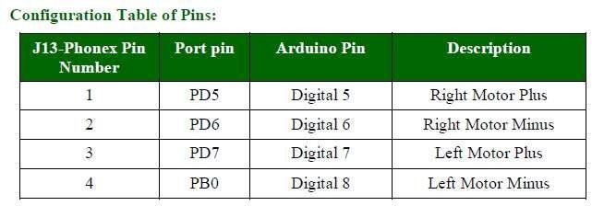

Table 9.1 Pin Configuration for RoboCar

**CODE :**

void forward()

{ digitalWrite(5,HIGH); digitalWrite(6,LOW); digitalWrite(7,LOW); digitalWrite(8,HIGH);

}

void backward()

{

digitalWrite(5,LOW); digitalWrite(6,HIGH); digitalWrite(7,HIGH); digitalWrite(8,LOW);

} void right() {

digitalWrite(5,LOW); digitalWrite(6,LOW); digitalWrite(7,LOW); digitalWrite(8,HIGH);

}

void left() {

digitalWrite(5,HIGH); digitalWrite(6,LOW); digitalWrite(7,LOW); digitalWrite(8,LOW); } void clockwise() { digitalWrite(5,LOW); digitalWrite(6,HIGH); digitalWrite(7,LOW); digitalWrite(8,HIGH); } void anticlockwise() { digitalWrite(5,HIGH); digitalWrite(6,LOW); digitalWrite(7,HIGH); digitalWrite(8,LOW); } void setup() {

Serial.begin(9600); pinMode(5,OUTPUT); pinMode(6,OUTPUT); pinMode(7,OUTPUT); pinMode(8,OUTPUT);

}

void loop() { forward(); delay(2000); backward();

delay(2000); right(); delay(2000); left();

delay(2000); clockwise(); delay(2000); anticlockwise(); delay(2000); }

**DIAGRAM:**

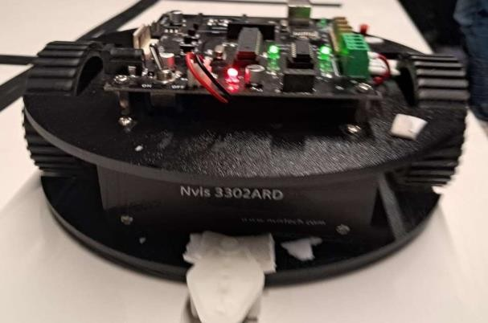

Fig 9.1 Nvis 3302ARD RoboCar

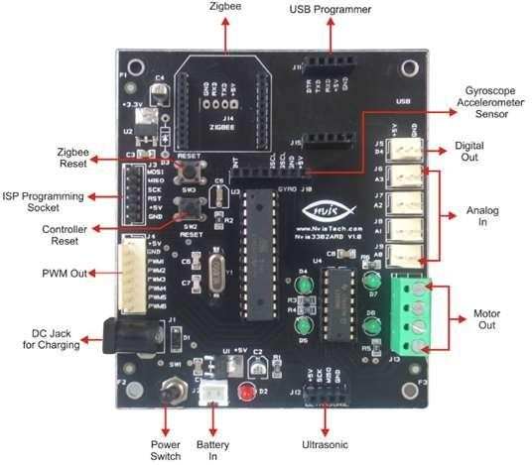

Fig 9.2 Board Configuration and part name

**RESULT ANALYSIS:**

In this Experiment, we successfully programmed RoboCar to perform basic functions that are Forward, Backward, Left, Right, Stop, Clockwise and Anti- Clockwise Direction. We learned how to implement code in RoboCar and learned basics about functioning and circuit of RoboCar.